Welcome to

Reception

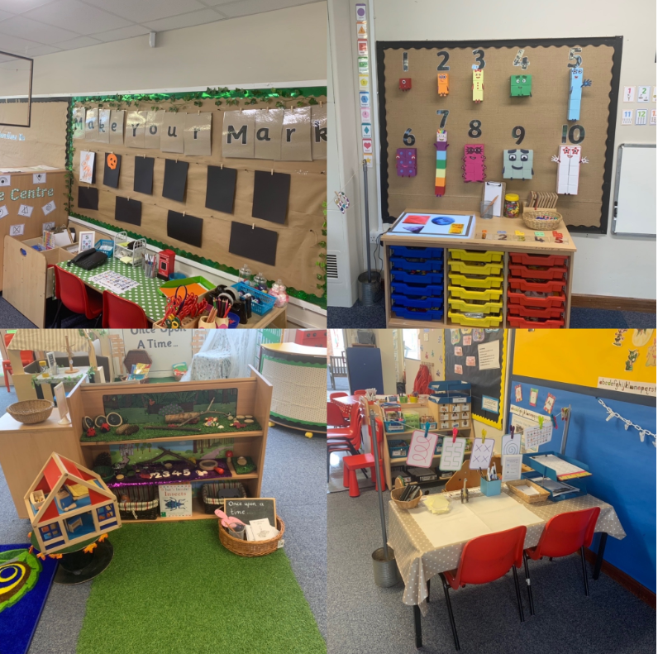

**@StantonCrossPri**

**Welcome**

We hope that your child is looking forward to starting school at Stanton Cross Primary School. We have written this booklet to help both you and your child as he or she starts school. We would like to take this opportunity to welcome you to school and if after reading this booklet you have any queries, please do not hesitate to discuss them with us. We are very proud of our Early Years Unit and hope that your child will be happy and excited to be joining us.

**Our Aims**

Starting at school is a very important milestone in your child’s (and your) life. We aim to provide a safe, stimulating and positive environment to help and support your child at this crucial stage in their development.

**The Early Years Foundation Stage Curriculum**

‘Early Years’ refers to the educational provision and learning opportunities provided for children aged 0-5 years.

At first glance, it can appear that the children are ‘only playing’. However, the best Early Years Education is based on the understanding that whilst children are playing, they are engaged and learning. Your child will begin their learning journey by working on a range of practical and play based activities. During the day there will be a mixture of adult initiated, child initiated and adult led learning opportunities as well as whole class, small group and individual activities.

The Early Years Foundation Stage (EYFS) is based on four themes and seven areas of learning.

[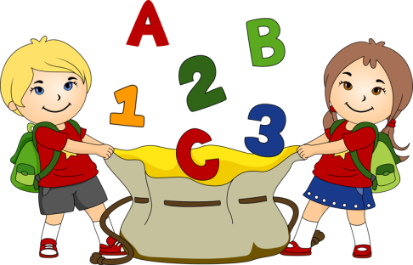](http://www.google.co.uk/url?sa=i&rct=j&q=school%20clipart&source=images&cd=&cad=rja&uact=8&ved=0CAcQjRw&url=http://androidkidsgames.blogspot.com/2015/05/top-free-preschool-learning-educational.html&ei=PU6JVaeaGZDW7QaPgbSwDA&bvm=bv.96339352,d.ZGU&psig=AFQjCNFs9a231U1xfYdR8N5_M-x6sNjz_A&ust=1435148177133760)These are:

1. **Communication and Language**

- Listening, Attention and Understanding - Speaking

1. **Personal, Social and Emotional Development**

* Self-regulation - Managing self - Building relationships

1. **Physical Development**

* Gross motor skills - Fine motor skills

1. **Literacy**

-Comprehension - Word reading - Writing

1. **Mathematics**

* Number -Numerical problems

1. **Understanding the World**

-Past and Present - People, Culture and Communities. - Natural World

1. **Expressive Arts and Design**

-Creating with Materials - Being Imaginative and Expressive

Each learning area has a number of stages which children work through; with the Early Learning Goals being the end of year assessment in Reception. We create a safe, welcoming and engaging learning environment where children ‘DARE’ to show ‘determination’ in all they do. They try their best in order to ‘achieve’ well and show ‘respect’ for themselves, others and the school. The children ‘enjoy’ their time in school and above all, ‘Achieve extraordinary things’. All experiences are planned across the EY unit to ensure that progression is made and speech and language is promoted through children discussing experiences across their time in Reception.

**Assessment in Early Years**

Within the first few weeks of starting Reception your child will be part of an extensive assessment programme. This will be mostly through ongoing, informal observations as well as the Governments own baseline assessment that all schools follow. You will be invited into Reception towards the end of the first term to talk about progress and outcomes and to share expectations.

**Meet the Staff**

**Mrs Louise Hinds**

**Early Years Practitioner**

**Miss Hannah Marks**

**Early Years Teacher**

**Miss Chloe Griffin**

**Early Years Teacher**

**Mrs Stacey Coote**

**Office Manager**

**Mrs Sara Smith**

**Teaching Assistant**

[](http://www.google.co.uk/url?sa=i&rct=j&q=school%20clipart&source=images&cd=&cad=rja&uact=8&ved=0CAcQjRw&url=http://cliparts.co/children-learning-pictures&ei=0k6JVdKkHoqP7AaSrYXIDQ&bvm=bv.96339352,d.ZGU&psig=AFQjCNF2UBdGAiz1S8LE55MzjgIBRyHkVQ&ust=1435148352194161)

**Our Reception Day for Term 1**

8.45am- Register and morning jobs

9.00am- Phonics- whole class

9.30am-11.25am- Continuous provision

11.25am- 12 noon- T4W (Monday)/ Maths (Tues-Fri)

12.00pm – 1:00pm - Lunchtime

1.00pm- 1.10pm- Kinetic Letters

1.10-1.30pm- Small group phonics

1.30pm-3.00pm- Continuous provision

3.00pm- Story time

3.15pm- Home time

**Handy hints to help your child settle in to Reception**

**There are many practical ways in which you can help your child before starting in Reception. These include, getting used to coming to school:**

* Talking to your child in a positive way about school in general, and what to expect.
* Introducing “school vocabulary” e.g. “classroom”, “playground”, “register” etc
* Helping your child to become more independent in activities such as; dressing, putting their coat on, wiping their nose, going to the toilet, hand-washing, eating etc.
* We encourage all Reception children to go to the toilet across the session. Although, children that are just getting used to a new setting may have occasional accidents, we are happy to assist your child where necessary. Please ensure they always have spare clothes in a named bag on their peg.
* Start getting them ready to eat lunch at school i.e. using a knife and fork independently or opening packets by themselves.
* We use Tapestry to share information. If you have photographs of family and friends who will be on your child’s contact sheet, then please upload a photo for us. It helps us know who is who.
* Making sure that your child knows what is his or hers (lunchboxes, clothing etc) and making sure that it is clearly named.

**Clothes:**

* Help your child become independent, let them get themselves dressed even if they get muddled up.
* **Velcro shoes are best**, children can manage these by themselves.
* Your child may get wet in the water tray or might not make it to the toilet in time, so spare clothes in their bag is essential.
* Getting changed can be very hard and clothes get muddled up, please label absolutely everything, including shoes! We are not responsible for un-named lost clothing.
* Some parents have found it helpful for their child to “practise” using their lunchbox/fastening coats and shoes before starting school, please try all these things the few days before your child starts.
* **Please provide your child with a pair of wellies** so that we can access our outdoor area all year round. Children will get messy – it is fun and part of the curriculum!

**Phonics:**

* We teach the children the sounds of letters **not** letter names to start with. Alphablocks on CBeebies use the same pure sounds that we teach:

<http://www.bbc.co.uk/cbeebies/watch/alphablocks-watch>

* Please make sure you use lower case letters when writing your child’s name e.g. Fred, Bobby, and Joe, not FRED, BOBBY and JOE.

**Starting School**

[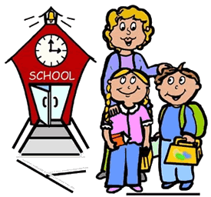](http://www.google.co.uk/url?sa=i&rct=j&q=parent+and+child+clip+art&source=images&cd=&cad=rja&uact=8&ved=0CAcQjRw&url=http://imagefriend.com/parent-and-child-clip-art.shtm&ei=qmGJVcuxEqLB7gba9YKoAw&psig=AFQjCNFM989mrQCVNRsSqqxHEuXVidCHeg&ust=1435153155229760)The Early Years Foundation Stage team place great emphasis on the value of home-school links. We encourage children to become independent once they have settled into their new learning environment. We ask that you encourage your child to do as much as possible for themselves.

**Home Time Procedures**

At home time, children are supported by two key adults. One adult to supervise your child, and one adult to supervise the exit gate. The adult on gate duty is responsible for calling your child’s name. We politely ask you to be patient waiting for your child, as we call a few children at a time to allow your child to leave safely. We also ask that if you need to speak with a member of staff that you wait until all the children have been called, again, this ensures that all the children remain safe and that you have the full attention of the staff member.

For your child’s safety we will ask for a list of named people who have your permission to collect your child from school and we ask that you let us know if your child will be collected by a person different from those already stated. We will also ask you to provide us with a password, so that in the event someone else collects your child a password will need to be given to the adult.

**How can you be involved in school life?**

We appreciate that no-one understands and knows your child as well as you do, therefore we place great importance on home and school links. We actively involve parents in their child’s learning and include these contributions to each child’s learning journey. We appreciate the time and commitment it takes to share your knowledge and contributions about your child and would like to thank you in advance for this support.

We use an online profiling system called ‘Tapestry’ in which you can upload photos of your child onto a secure system for us to see. More information on this will be shared with parents during home-visits. Across the year we will post on Tapestry asking for photo’s, pictures, items to support your child in school as we just love to see what wonderful things your child has been doing at home.

Parents' evenings are held twice a year and these are an excellent opportunity to discuss progress as well as new targets. We will offer workshops and class events to show you what your child does during their time in school including, stay and play sessions. We will continue to keep you informed of what is happening in school by using Newsletters, Twitter, Facebook and Tapestry.

When your child reads in school we will record this in their reading record and would like you to do the same when they read or share a story with you at home.

**Reading and Phonics**

**Phonics**

Being able to read is the most important skill children learn during their early schooling and has far-reaching implications for lifelong learning, conﬁdence and well-being. High quality phonic teaching is the prime means by which, we teach children how to read and spell words.  
At Stanton Cross Primary School, we follow the ‘Read, Write Inc’ phonics programme. We will hold a phonics workshop in the Autumn term. Our Reading scheme, Read, Write Inc, which supports early reading and synthetic phonics. The books match the phonemes that the children are learning in their phonics lessons.

**Home Reading**

At Stanton Cross Primary School, we expect our children to read at home every day. Additionally we will also encourage children to share a ‘Reading for pleasure’ book once a week. Reading at home is a vital part of education as it builds a wealth of vocabulary as well as supporting retrieval and inference questioning.

Tips to support your children with reading at home:

· Set reading time aside and ensure you have no distractions when reading.

· Ask your child to choose a book as it will support children’s recommendations and the idea of book talk.

· Discuss the illustrations, as this will support inference questioning.

· Encourage your child to talk about the book.

· Make it fun! Read in a funny voice, have a prop or show different actions.

**Please ensure that you write in your child’s reading record each time you read with them.**



Our school Website has lots of links to interactive sites that you can visit to support learning.

**School Uniform**

* **The school will provide your child with a bookbag. You do not need to purchase this.**

Uniform can also be purchased at <https://www.uniformshopwellingborough.co.uk/>

Reception children will be out in all weathers. Please ensure that your child has a coat and wellington boots in school every day. **Please name everything, especially shoes!**

**If you do not name your child’s clothing, we cannot return this to you.**

**What should I bring to School?**

**Weather appropriate outdoor clothing**

Warm waterproof coats, hats, scarves in winter.

Sun hats and apply sun cream before school, during the summer.

Please be aware that your child will have continuous access to our outside provision during all weathers.

**Spare clothes in a named bag that can be left in school.**

This is essential for all children, even if you know that your child no longer has toileting accidents. All children will have access to water, mud and paint every day!

**A Book Bag-All children** will need a book bag. This is to take home reading for pleasure books, school reading books, key word cards and any other information. We will provide you with one on entry to Reception.

**The school cannot accept responsibility for any toys or personal objects that are brought into class. It is an impossible task for staff to keep track of all toys that enter the classroom, please encourage your child to leave their things with you at the door, or place in their bookbag. Lost Property is put out once a week and will be disposed of at the end of the school week.**

**Snack**

[](http://www.google.co.uk/url?sa=i&rct=j&q=milk+clipart&source=images&cd=&cad=rja&uact=8&ved=0CAcQjRw&url=http://www.clipartpanda.com/categories/milk-carton-clipart-black-and-white&ei=PFGJVf6vJ4ac7gaxpoGYBw&bvm=bv.96339352,d.ZGU&psig=AFQjCNHiBaklP9nellwHEHcxuCi0p20AWA&ust=1435148907507190)In Reception, children are introduced to new and exciting foods, often linked to our topics or a celebration. We use snack time each day to promote eating a healthy and varied diet. The children have a mid-morning or mid-afternoon snack of fruit and milk which they are encouraged to make themselves.

**Children in EYFS are entitled to free milk up until their 5th Birthday.**

**Lunchtime**

Meals are freshly cooked daily, with a variety of meat and vegetarian selections and meet the required national nutritional standards, providing a varied and balanced diet for the children, through both hot food and packed lunch options.

You will need to use our online system to book school lunches. You will be given a username and password before your child starts school.

All children in Reception are entitled to a free school meal, both a hot or cold food choice.

**Children bringing a packed lunch from home.**

Lunchboxes must contain healthy food options such as:

[](http://www.google.co.uk/url?sa=i&rct=j&q=lunch+box+clipart&source=images&cd=&cad=rja&uact=8&ved=&url=http://www.clipartheaven.com/show/clipart/education_&_schools/classroom_&_activities/school_lunch_3-gif.html&ei=BFSJVenFKIuu7gbH46XgBA&bvm=bv.96339352,d.ZGU&psig=AFQjCNF9Ry1Qqj8lWFewqlmbn5ndBuII9w&ust=1435149701069515)Sandwich, crackers etc

Cheese strings

Yoghurt

Fresh fruit

Please do not include sweets or fizzy drinks, thank you.

We are a no nut school and so please bare this in mind when making packed lunches for your child.

[](http://www.google.co.uk/url?sa=i&rct=j&q=telephone+clipart&source=images&cd=&cad=rja&uact=8&ved=0CAcQjRw&url=http://cliparts.co/clip-art-phone&ei=_FSJVYarE4rk7Aacy4OYBA&bvm=bv.96339352,d.ZGU&psig=AFQjCNHVV8DjfMLgCxtQLJZImwzKQ0f-Nw&ust=1435149920197878)

**Attendance Policy**

Families, parents and children, learn quickly about the expectations of school attendance.  It is important that it is given priority in daily life. Regular and punctual attendance enables children to succeed, develop social relationships and to develop effective life skills. The importance of regular attendance is explained on the home visit and forms the basis of the Home School Agreement. All parents and carers will be expected and encouraged to ensure their child achieves the maximum attendance possible. We understand that there are times when circumstances impact on attendance. Staff will support parent/carers in cases of difficulty by discussion of strategies or timings. We also acknowledge that children are susceptible to childhood illnesses.  If your child is suffering from a sickness bug then they can return to school after a period of **24 hours** from the last time they were sick.  Parents/Carers must inform the office if a child will be absent.

**If your child is ill or unable to attend school for any reason please ring the school office on:**

[01933](https://www.google.com/search?q=highlees+phone+number&rlz=1C1GCEA_enGB970GB972&oq=highlees+phone+number&aqs=chrome..69i57.3932j0j7&sourceid=chrome&ie=UTF-8&safe=active&ssui=on) 594049

**Please leave a message on the school answer phone if you are unable to speak to someone.**

Monitoringattendance at school will support the safeguarding of children. Unexplained absences, holidays during term time and attendance that falls below 95%, will all trigger actions by staff. Staff will contact parents and a meeting will be held to support children and families in ensuring children are in school on time, every day.

**Procedure**- Attendance is recorded daily in the register by the Class Teacher. All parents must contact the school on the first day of absence with the reason for that absence. If the school receives no reason for absence, the office will contact the family. Children subject to a Child Protection plan will be contacted on the day of absence. The Office Manager and Head Teacher will monitor patterns of regular absence and, where necessary. ascertain reasons for this and seek to remedy the situation if appropriate or refer to other agencies.

**Requests for holidays during term time**

The DfE regards the taking of holidays during school time as an exception and not a rule. Therefore, parents should do all they can to avoid holidays in school time.

For more information please follow the link:

<https://www.gov.uk/school-attendance-absence/legal-action-to-enforce-school-attendance>

Requests for leave of absence should be made a minimum of four weeks in advance. Leave of Absence forms are available on request only from the main office.

**Behaviour and Relationships**

Our aims:

* To support children to be kind and caring towards others and living things.
* To encourage children to be proud of their environment and look after it.
* To model taking care with resources and supporting children to do the same.
* To support children to share with others.
* To work with children to build their self-esteem and recognise their own uniqueness and worth.
* To help children understand that at school, home and in the wider community their opinion counts, as does the opinion of others.

We acknowledge that children within the Early Years Unit are at different stages of development and understanding. All children have different experiences of relationships and behaviour. It is important to us that all staff support children as individuals and work with families to enable children to be resilient individuals, able to build relationships and work in the environment in a positive way. We support children by acknowledging and allowing the feeling of the child, but ensuring we set the limit of acceptable ways of displaying the feelings. We see it as our role, to support our children, to understand their own emotions and the emotions of others, plus find positive ways to show how they are feeling. We believe children are able to cope better with emotion if they understand it, plus it supports self-regulation that will support them for the rest of their lives. We want to make it clear we do not condone unacceptable behaviour and the safety of all children is paramount.

It is important that all staff are fair and consistent with their expectations of behaviour, and are also consistent when dealing with behaviour. We use a three step approach. The steps do not necessarily go in the same order each time, all children and situations are different.

|  |  |  |
| --- | --- | --- |
| Acknowledge the feeling of the child | * Name it * Sympathise with the child | * You look a bit cross/sad   • I don't like seeing you cross  • I wonder what made you so cross/sad  • I wonder whether you are sad because …… is playing with……  • It's not nice when you can't have something, it can be difficult to share |
| Set the limit | * Make it clear it is acceptable to feel cross/sad/angry/, however the way in which they chose to show it was not acceptable | * I know you are sad that …. is playing with…. , but we can't hurt our friends.   • I know you are cross about the train, but we don't throw toys, it could really hurt someone  • I know you are really sad today, but we can't throw things-you might hurt somebody, or even yourself, we don't want that. |
| Problem solve | * Consider positive ways of showing emotion * If another child involved, how can we make them feel better? * Find a solution to the problem | I wonder what you could do when you are cross next time? Go play somewhere else? Go outside and run around? Stamp your feet?  • Poor ____, she's hurting now, I wonder what we could do make them feel better? Give hug, checks she is alright?  • If you can't have the bike now, maybe ask if you can have it next? Find another bike? Do something different whilst you wait? |

The level of understanding a child has is an important factor when dealing with behaviour. Communication is adjusted accordingly, such as; body language, tone of voice and level of language being used. We value the importance of supporting other children to understand the communication behind any behaviour to help them recognise why a child may have reacted in a certain way. We believe this helps children build positive relationships with others and helps them to recognise the feelings of others, plus help them to feel safe and be able to cope with unpredictable behaviours.

When children become very frustrated and clearly unable to move on from a situation, staff will move the child away in order to help them to calm down. If appropriate, the child may go to another area within the unit, a change of scene can help regulate emotions. A staff member will remain with the child until they are calm. If the child is able, the adult might share a book with them, play a game or carry out an activity to enable the child to refocus their energy elsewhere.

Strategies that involve shouting, humiliating children or punishment are not used at Stanton Cross Primary School. We recognise the importance of supporting and working with our children to understand the boundaries in school, at home and the wider world in order to build successful and positive relationships. It is important to us that children understand why a boundary is in place and why certain behaviours are not acceptable.

On occasions where the child is unable to calm down or repeated poor behaviour choices are made which involve threats or actual violence to others, then the child will be given thinking time to calm away from the other children to prevent further harm.

We acknowledge that some children find attending school with other children a challenge, sharing resources, being away from home, along with barriers to development in the form of language can cause children to become physical and/or display challenging behaviour. It is important to us to understand the triggers for certain behaviours to be able to successfully support that child to understand how they are feeling, help them to understand the impact their behaviour has on others, and consider alternative reactions. Behaviour is often used as communication and we will use records of incidents to help support the child in being able to communicate in more appropriate ways.

To help us with our understanding and to enable us to best support them we will complete a behaviour chart that allows us to see patterns in behaviour and gain an insight into what that child is trying to communicate to us through their behaviour. Communication with parents is essential to make sure that effective ways forward are planned. This may be in the form of daily feedback from your child’s key person, or from time to time will involve the SENCo, Assistant Head or Head Teacher. If challenging behaviour is seen consistently then staff will speak with parents about making referrals to support services and the pre-five health team. We recognise that it can be difficult to accept that your child is finding certain aspects of school difficult, however we want to assure you we want to work with you and your child to enable them to be happy and thrive. Being happy and secure in the setting enables development in all areas.

We are really looking forward to you and your family being part of Stanton Cross Primary School.

[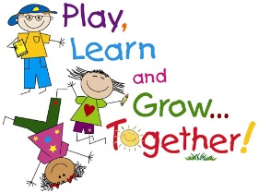](http://www.google.co.uk/url?sa=i&rct=j&q=school%20clipart&source=images&cd=&cad=rja&uact=8&ved=0CAcQjRw&url=http://rooseveltunioncity.sharpschool.com/&ei=bU6JVb7vEZCp7AaihoPICg&bvm=bv.96339352,d.ZGU&psig=AFQjCNHUBrm-0Zk7EV2iAdPyci-eAhG9FQ&ust=1435148264452710)